- Please COPY your answer to the question 3 in Project 1.
In my opinion perspective, AI-assisted tools is only advantageous The use of AI-assisted tools can prove advantageous when you use it critically. This , which means that you should not fully rely it is imperative not to rely entirely on AI to write academic English for the composition of academic English, instead, AI should be an advisor and enlightener ; instead, use AI as an advisor and a source of insight. For example instance, even if you have no idea how to write have difficulty writing an academic English phrase, it’s it is better to first try to write try writing it by yourself independently, and then to ask AI to revise your words. After that, you can Ccompare the AI-generated work with your own work to find out your mistakes and how to correct them. Please also remember It is also essential to bear in mind that AI is not always right. If you do not treat Without treating the AI-generated work critically, you will may only find that you can’t cannot improve your English writing because the mistakes possible errors by AI in your AI-revised work are not found and corrected. In a nutshell, as long as you do not rely fully entirely on AI-writing and view the contents generated by it critically, you can learn a lot from it.

- Please attach the photo of your essay that was revised by your peer.
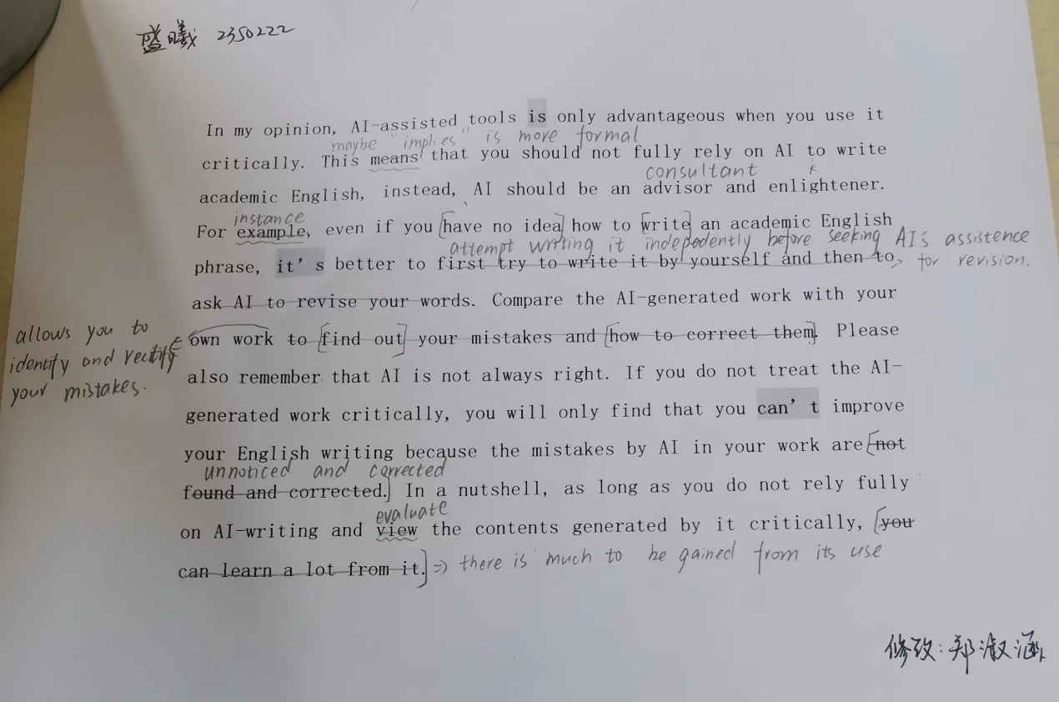

- Please transcribe the text from photo 2, and apply the modifications shown in photo 2 using track changes mode.
Please add annotations (新建批注)to each revision for the purpose of evaluating the revisions one by one that was made by your peer.
In my opinion, AI-assisted tools is only advantageous when you use it critically. This means implies that you should not fully rely on AI to write academic English, instead, AI should be an advisor and enlightener consultant. For example instance, even if you have no idea how to write an academic English phrase, it’s better to first try to write it by yourself and then to ask AI to revise your words attempt writing it independently before seeking AI’s assistance for revision. Compare comparing the AI-generated work with your own work to find out your mistakes and how to correct them allows you to identify and rectify your mistakes. Please also remember that AI is not always right. If you do not treat the AI-generated work critically, you will only find that you can’t improve your English writing because the mistakes by AI in your work are not found and corrected unnoticed and corrected. In a nutshell, as long as you do not rely fully on AI-writing and view evaluate the contents generated by it critically, you can learn a lot from it there is much to be gained from its use.

- Please use AI-assisted tools that we mentioned in class to revise your original essay.
  - Attach the original essay that you wrote in class.
In my opinion, AI-assisted tools is only advantageous when you use it critically. This means that you should not fully rely on AI to write academic English, instead, AI should be an advisor and enlightener. For example, even if you have no idea how to write an academic English phrase, it’s better to first try to write it by yourself and then to ask AI to revise your words. Compare the AI-generated work with your own work to find out your mistakes and how to correct them. Please also remember that AI is not always right. If you do not treat the AI-generated work critically, you will only find that you can’t improve your English writing because the mistakes by AI in your work are not found and corrected. In a nutshell, as long as you do not rely fully on AI-writing and view the contents generated by it critically, you can learn a lot from it.
4.2 Attach the essay that was revised with the assistance of AI-assisted tools.
Please add annotations (新建批注)to each revision for the purpose of evaluating the revisions one by one that was made by AI-assisted tools.
In my opinion, AI-assisted tools is are only advantageous when you use it used critically. This means that you should not fully rely on AI to write academic English, instead . Instead, AI should serve as an advisor and an enlightener. For example, even if you have no idea how to write an academic English phrase, it’s better to first try to write it yourself and then ask AI to revise your words. Compare the AI-generated work with your own work to find out your mistakes and how to correct them. By comparing the AI-generated work with your own, you can identify your mistakes and learn how to correct them. Please also It is also important to remember that AI is not always right. If you do not treat the AI-generated work critically approach AI-generated content critically, you will only find that you can’t not improve your English writing because the any mistakes made by the AI are not found and corrected will remain uncorrected. In a nutshell, as long as you do not fully rely on AI-writing AI for writing and view the contents generated by it critically critically assess the content it generates, you can learn a lot from it.

5. Reflection
5.1 根据此次使用AI工具帮助修改作文的经历，你觉得使用AI工具对修改作文有帮助吗？ 有的话，请具体讲一下怎样帮助的；没有的话，为什么呢？（Based on this experience of using AI-assisted tools to revise your essay, do you think AI-assisted tools can help with improving your English academic writing? If yes, please explain it. If not, why）
Yes, I think AI-assisted tools are helpful. AI helps make essays more accurate and professional because it is always objective and has access to vast databases. When real people revise an essay, they may be influenced by personal habits and emotions. Additionally, AI makes my writing more concise. As non-native speakers, it is often challenging for us to express ourselves accurately without losing conciseness. AI can help me find words, phrases, and sentence patterns that are both accurate and concise.
5.2 请谈谈你对同伴互批作文的看法。(What do you think of peer revision?)
I think peer revision is very helpful. When I revise my own essay, it is hard not to get stuck in my own mindset, which means I may repeat similar or even the same mistakes. When a peer revises my essay, they can provide a new perspective on how to convey the same meaning. This can broaden my mindset. I also learn a lot when I revise others’ essays. This exposes me to a variety of mistakes made by others, reminding me not to make those mistakes.
Additionally, I can learn from the good sentences written by others.
However, there are also drawbacks. The quality of feedback in peer revision is not guaranteed, as my peer may not be better than me in academic English writing.
5.3 请根据你自己和小伙伴批改的作文，比较一下自己修改作文和同伴批改作文的利弊，哪种好呢，为什么？(Based on your experience of revising your own essay and having your essay revised by your peer, please compare and contrast self-revision and peer revision. Which one do you prefer? Why?)
I think combining the two revising approaches is beneficial. Revising my own essay helps me develop critical thinking and encourages me to think outside the box, but some mistakes may remain unnoticed. Peer revision broadens my perspective, though the quality of feedback may vary. Therefore, I believe it is best to combine both approaches. By comparing my own revisions with those of my peers, I can identify overlooked mistakes and gain diverse perspectives. This way, my peers and I can progress together.

